**Week 18: Lets Go Splunking!**

**Step One:**

* The Approximate date and time of the attack was 02/23/2020 at 2:30pm.
* It took the system 9 hours to recover.

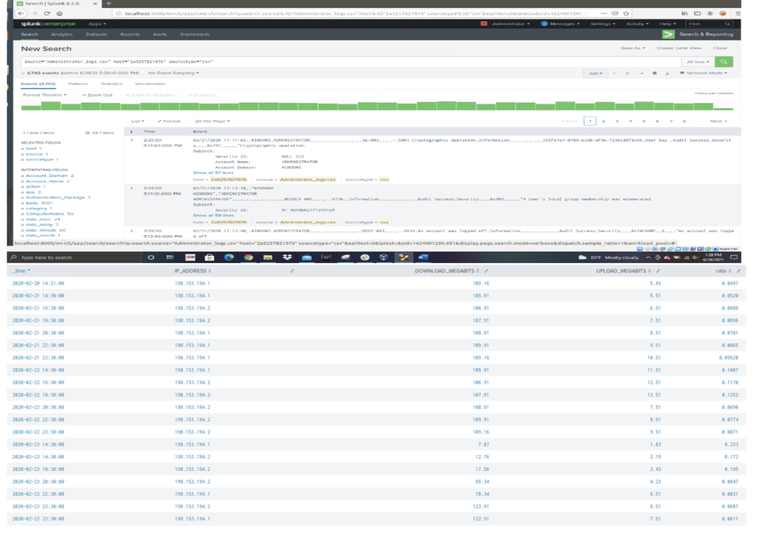

**Step Two:**

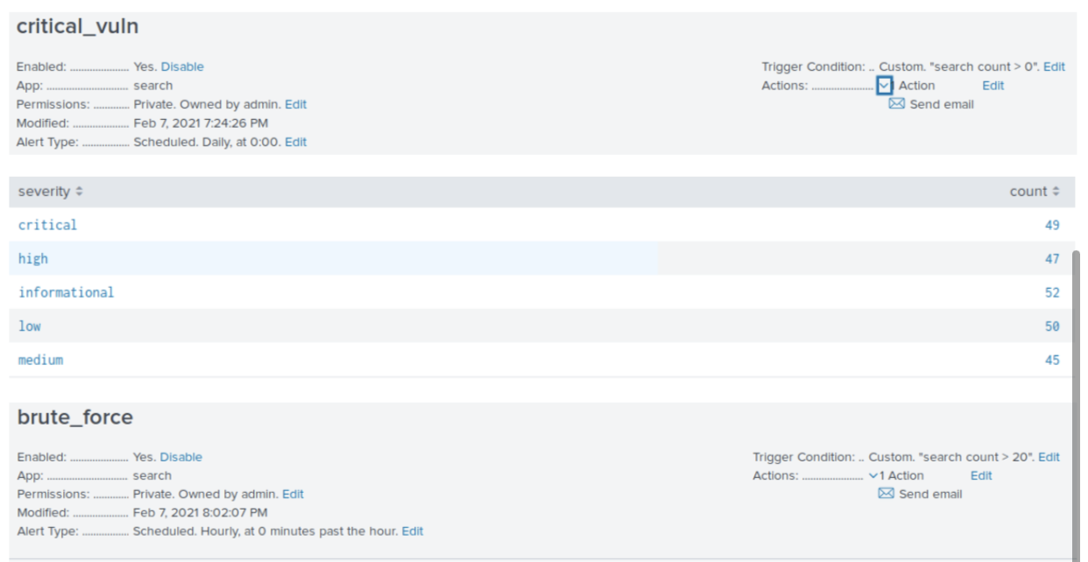

**Step Three:**

* The determined baseline is 25 logins per hour and my threshold is a count greater than or equal to 35

